**Big Data Analysis with IBM Cloud Databases**

**Phase 5: Project Documentation & Submission**

* Outline the project's objective, design thinking process, and development phases.
* Describe the selected dataset, database setup, analysis techniques, and visualization methods used.
* Explain how the analysis findings translate into valuable business insights.

**Problem Definition:**

* The project involves delving into big data analysis using IBM Cloud Databases. The objective is to extract valuable insights from extensive datasets, ranging from climate trends to social patterns. The project includes designing the analysis process, setting up IBM Cloud Databases, performing data analysis, and visualizing the results for business intelligence.
* In an era marked by increasingly frequent and severe climate-related events, there is a pressing need to understand and mitigate the social and community impacts stemming from these trends. Climate change, including rising temperatures, extreme weather events, and changing precipitation patterns, is disrupting ecosystems and directly affecting communities worldwide. These climate trends are exacerbating existing social patterns of vulnerability, leading to disproportionate harm to marginalized populations, strained community resilience, and increasing disparities in access to resources, health, and economic opportunities. The challenge lies in developing comprehensive strategies that not only mitigate the effects of climate change but also address the social patterns that render certain communities more susceptible to its consequences. Finding solutions requires a multi-faceted approach that acknowledges the interconnectedness of climate and society, involving collaboration among policymakers, researchers, community leaders, and stakeholders from diverse backgrounds.

**OBJECTIVES**

1. **Trend Identification and Analysis:**
   * **Objective:** Identify and analyze long-term climate and temperature trends to understand the direction and magnitude of changes over time.
   * **Rationale:** To quantify and comprehend the scope and scale of temperature shifts and climate variability.
2. **Anomaly Detection:**
   * **Objective:** Detect anomalies, such as extreme weather events or unexpected deviations in temperature patterns.
   * **Rationale:** To highlight unusual and potentially concerning shifts in climate that might require attention or further investigation.
3. **Regional and Global Pattern Recognition:**
   * **Objective:** Discern regional and global patterns of temperature changes to understand spatial variations.
   * **Rationale:** To determine how different regions or areas are affected and to identify potential hotspots of climate change impact.
4. **Correlation Studies:**
   * **Objective:** Investigate relationships between temperature changes and other climatic variables, such as precipitation, humidity, and sea level.
   * **Rationale:** To understand the interconnectedness of various environmental factors and their contributions to temperature alterations.
5. **Predictive Modeling:**
   * **Objective:** Develop predictive models to forecast future climate and temperature trends based on historical data.
   * **Rationale:** To anticipate potential future scenarios and support preparedness and adaptation measures.
6. **Impact Assessment:**
   * **Objective:** Evaluate the impact of changing temperature trends on ecosystems, agriculture, infrastructure, and human populations.
   * **Rationale:** To understand the repercussions of these changes and develop strategies to mitigate negative effects.
7. **Policy Support and Decision-making:**
   * **Objective:** Provide data-driven insights to policymakers for informed decision-making in creating climate change policies.
   * **Rationale:** To inform policies and regulations that can mitigate and adapt to changing climate conditions.
8. **Public Awareness and Education:**
   * **Objective:** Communicate findings to the general public to increase awareness and understanding of climate change impacts.
   * **Rationale:** To foster public engagement and support for climate action through informed knowledge.
9. **Research and Collaboration:**
   * **Objective:** Encourage collaboration between researchers, scientists, and institutions to continually study and address changing climate patterns.
   * **Rationale:** To foster a collaborative approach in understanding, adapting to, and mitigating climate change effects.

**DESIGN THINKING**

1. **Data Selection:**

In the data selection phase, you'll identify and gather the datasets that are relevant to your analysis objectives. This involves:

* Identifying the sources of data, whether it's publicly available data, data from internal databases, or data collected through various sensors or sources.
* Ensuring that the chosen datasets cover a range of topics, from climate trends to social patterns, and are of sufficient quality and quantity to support meaningful analysis.
* Documenting the metadata for each dataset, including data format, update frequency, and any data preprocessing required.

1. **Database Setup:**

Database setup is a critical step in your project, and it involves:

* Choosing the appropriate IBM Cloud Database service based on the nature of your data and analysis requirements. Options may include SQL databases (like Db2) or NoSQL databases (like Cloudant).
* Creating the database instances, defining the schema (for SQL databases), and configuring security measures such as access controls and encryption.
* Ensuring that the database architecture is scalable to accommodate the large volumes of data you'll be working with.

1. **Data Exploration:**

Data exploration is where you dive into the datasets to understand their characteristics. Key tasks include:

* Writing queries and scripts to retrieve sample data from the database for initial exploration.
* Performing basic statistical analysis to summarize data distributions, identifying missing values, and detecting outliers.
* Visualizing summary statistics and initial insights to get a sense of the data's structure and potential patterns.

1. **Analysis Techniques:**

In the analysis techniques phase, you'll decide on and apply the specific methods and algorithms for extracting insights. This includes:

* Choosing appropriate analysis techniques based on your research questions, such as regression analysis for climate trends or sentiment analysis for social media patterns.
* Developing custom scripts or utilizing pre-built analytics tools to conduct the analysis.
* Ensuring that you have the necessary computational resources and infrastructure for complex analyses, especially for big data.

1. **Visualization:**

Visualization is crucial for making your findings understandable and actionable. Consider the following:

* Creating visualizations that effectively communicate your analysis results, such as line charts for climate trends or word clouds for social media sentiment.
* Using interactive tools or dashboards to allow stakeholders to explore the data and insights on their own.
* Ensuring that your visualizations are accessible and user-friendly for a broad audience.

1. **Business Insights:**

The ultimate goal of your project is to derive actionable business insights from the analysis. This involves:

* Interpreting the analysis findings in the context of your project's objectives, whether it's for decision-making, strategy development, or research.
* Formulating clear and concise recommendations based on the insights, emphasizing their potential impact on business or research goals.
* Communicating the insights and recommendations to stakeholders in a compelling and understandable manner.
* By following these steps, you can systematically approach your big data analysis project using IBM Cloud Databases and maximize the value of the insights you extract from your extensive datasets.

**Development Part 1**

* Start building the big data analysis solution using IBM Cloud Databases.
* In today's data-driven world, businesses and organizations are constantly seeking insights and actionable information from large datasets. Big data analysis has become a crucial part of decision-making, and IBM Cloud Databases provide a robust platform for building and deploying data-driven solutions. This guide introduces the process of creating a big data analysis solution using IBM Cloud Databases, a multi-step approach to harness the power of your data.

**Step 1: Setting Up the Database**

* The foundation of any data analysis project is the data itself. To begin, you'll need to create an IBM Cloud account and choose the appropriate database service. IBM offers a range of database options, including Db2 and MongoDB, depending on your specific requirements. Once you've selected the service, set up a database instance where your data will be stored and managed.

**Step 2: Data Exploration and Basic Cleaning**

* This step often involves running queries or scripts to retrieve relevant data. Basic data cleaning and transformation may also be necessary to ensure data quality. As an example, SQL queries like the one provided in the guide can be used to retrieve specific data and calculate simple aggregates like averages.

**STEP-1 : Data Selection**

In the data selection phase, you'll identify and gather the datasets that are relevant to your analysis objectives. This involves:

* Identifying the sources of data, whether it's publicly available data, data from internal databases, or data collected through various sensors or sources.
* Documenting the metadata for each dataset, including data format, update frequency, and any data preprocessing required.
* This file in CSV (comma-separated values)

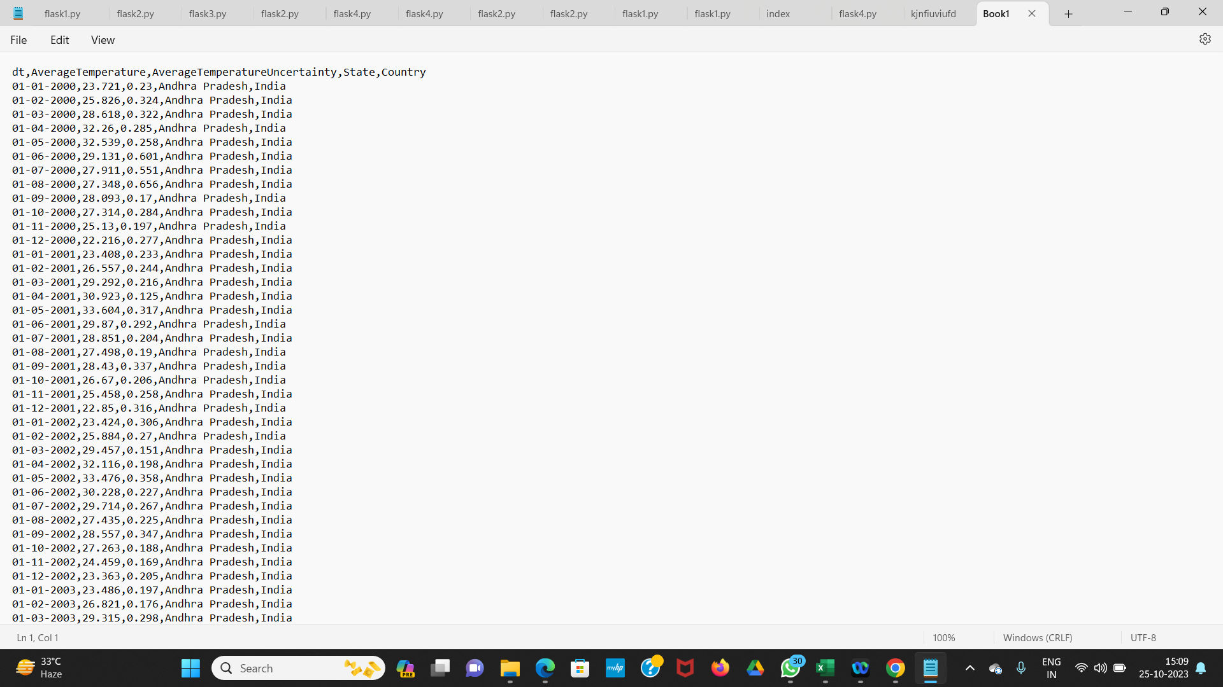

**STEP-2 : Database Setup:**

* Choosing the appropriate IBM Cloud Database service. Options may include SQL databases (like Db2).
* Creating the database instances, defining the schema (for Db2 databases).

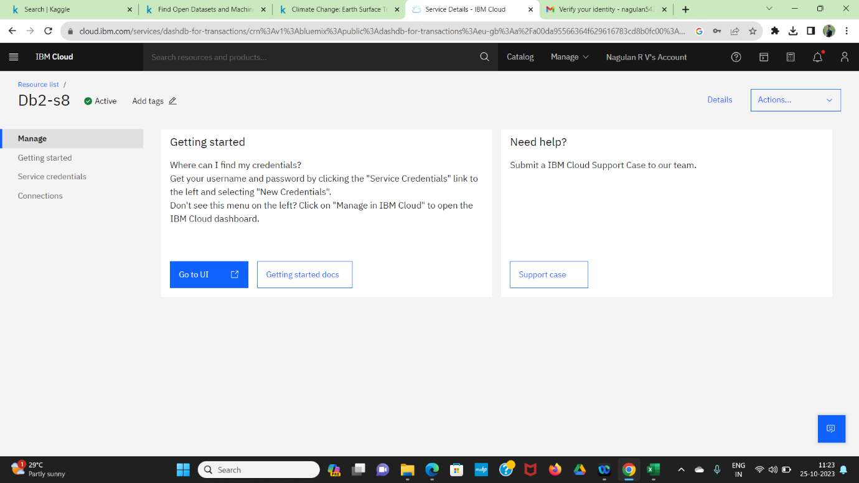

* Click the Go to UI

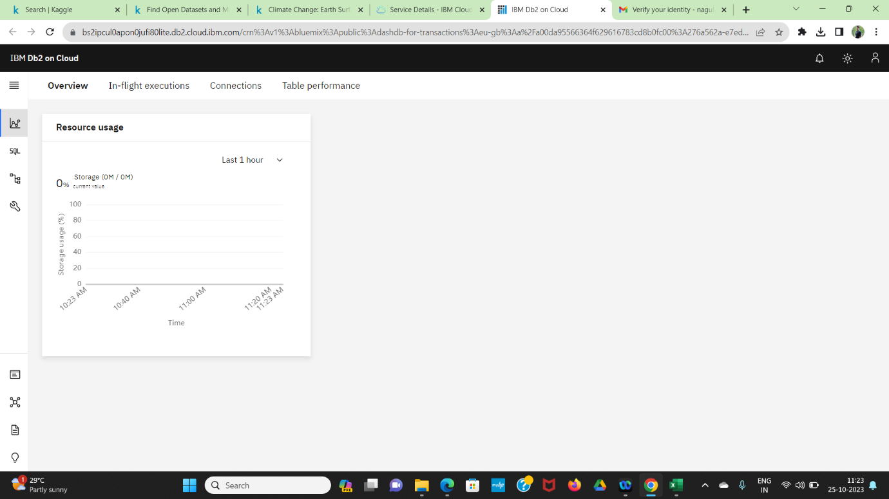

* Click the data which shown below

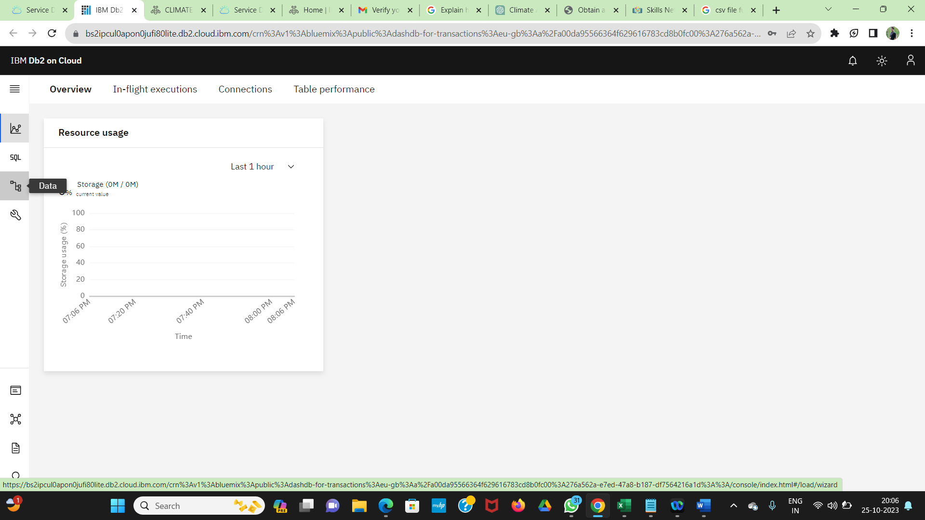

* After that drag the file and upload the file.

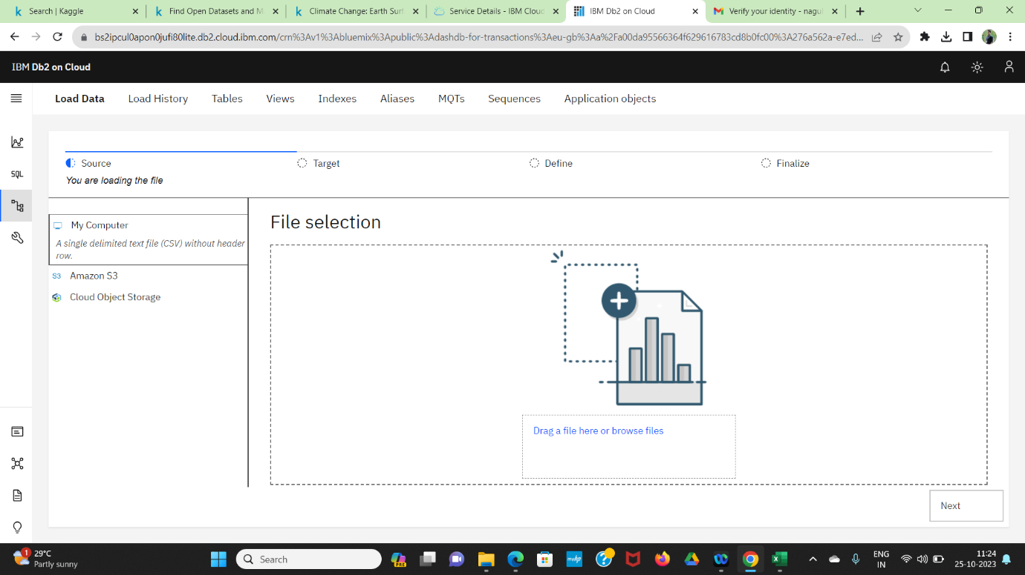

* After uploaded the file click the next button

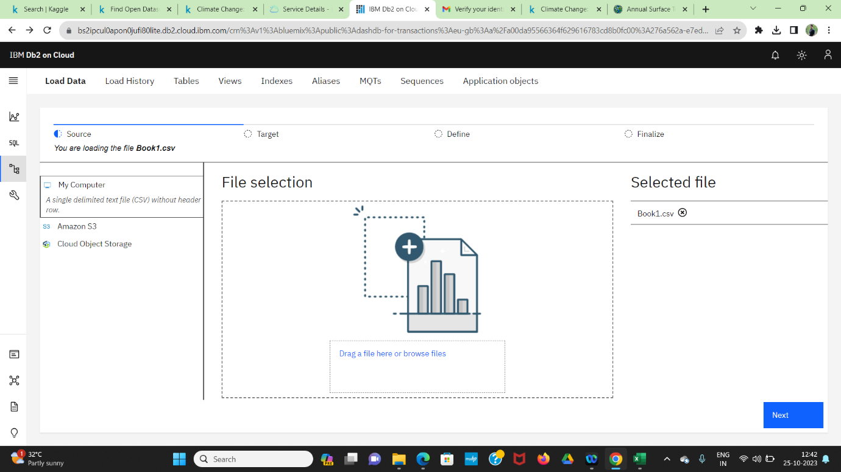



* Click the Schema (KKR49912) after that add a new table

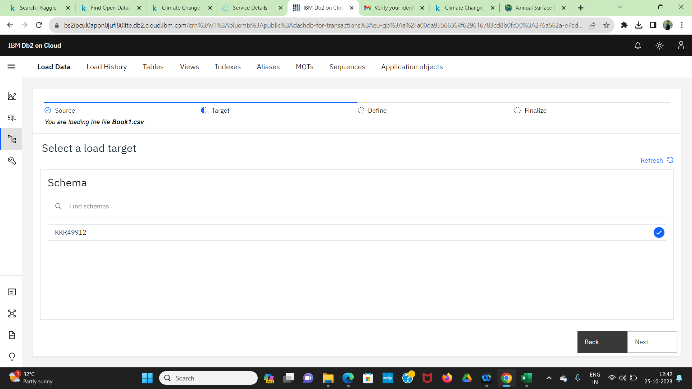

* Click next button.

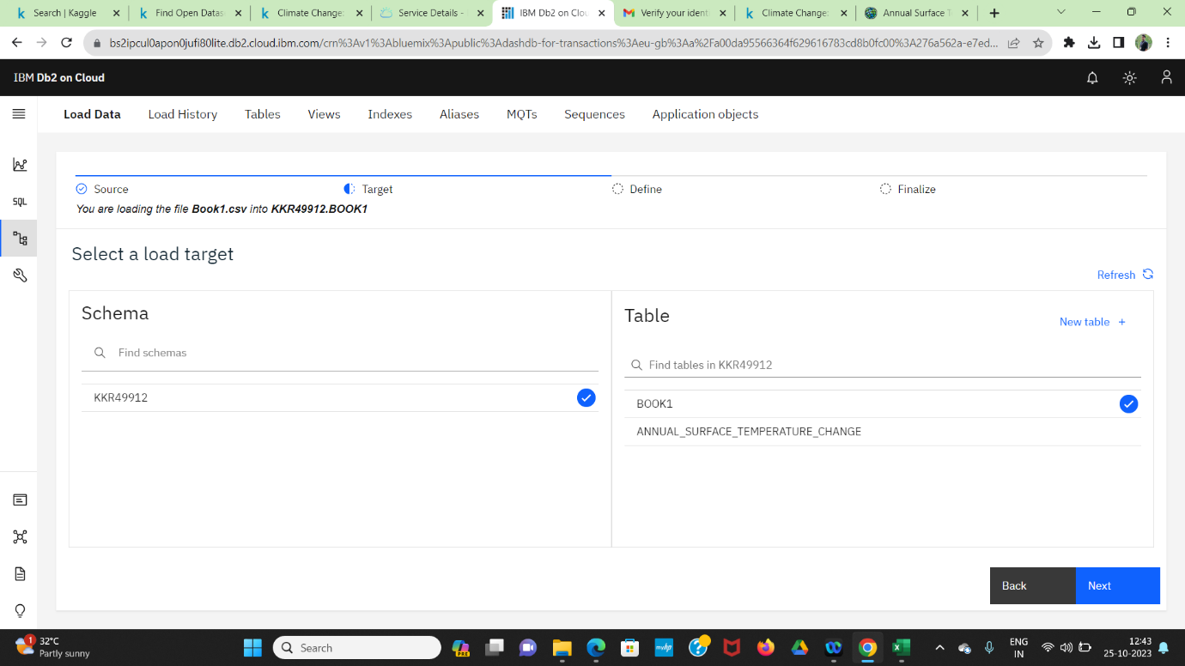

* Again click next button

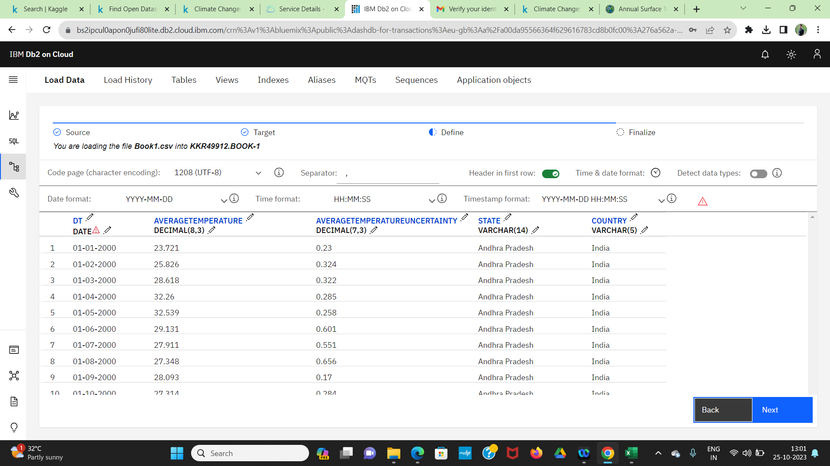

* Click the Begin load

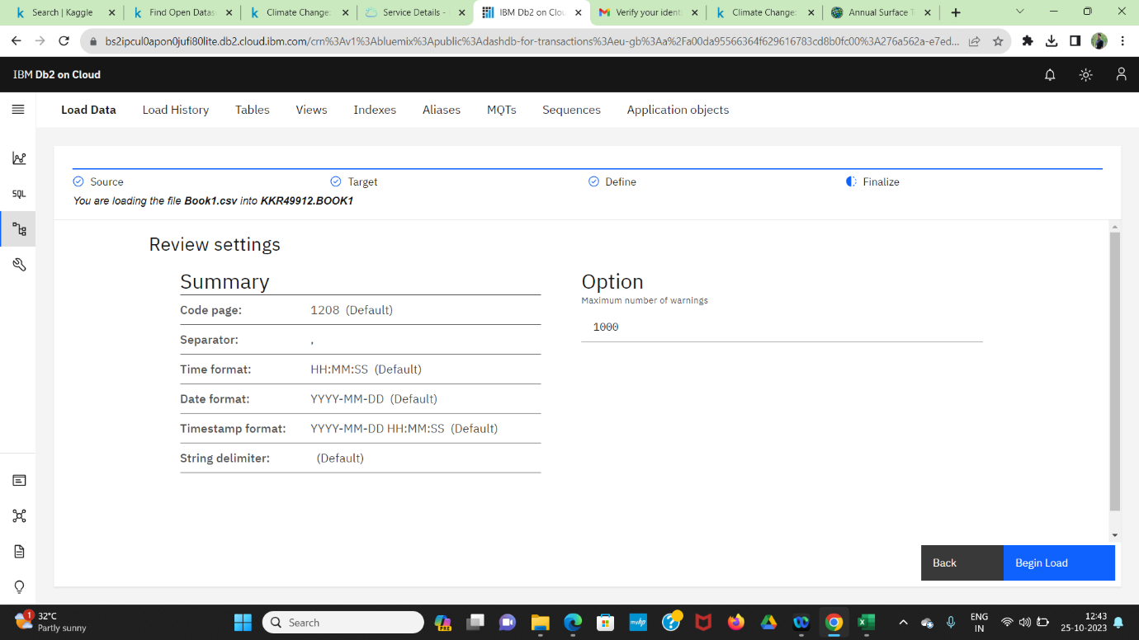

* After that it will start to uploading…….

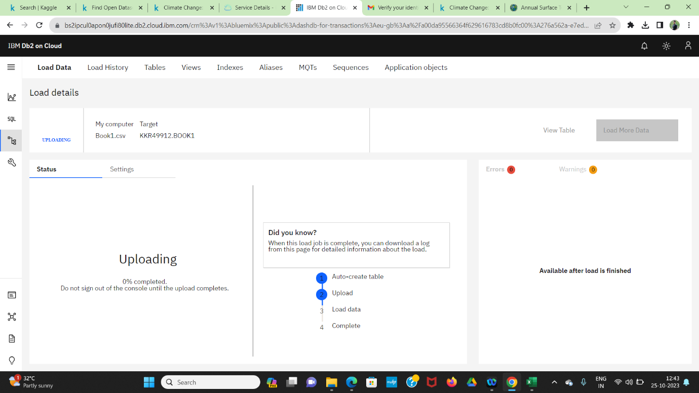

* Check the error and warning.

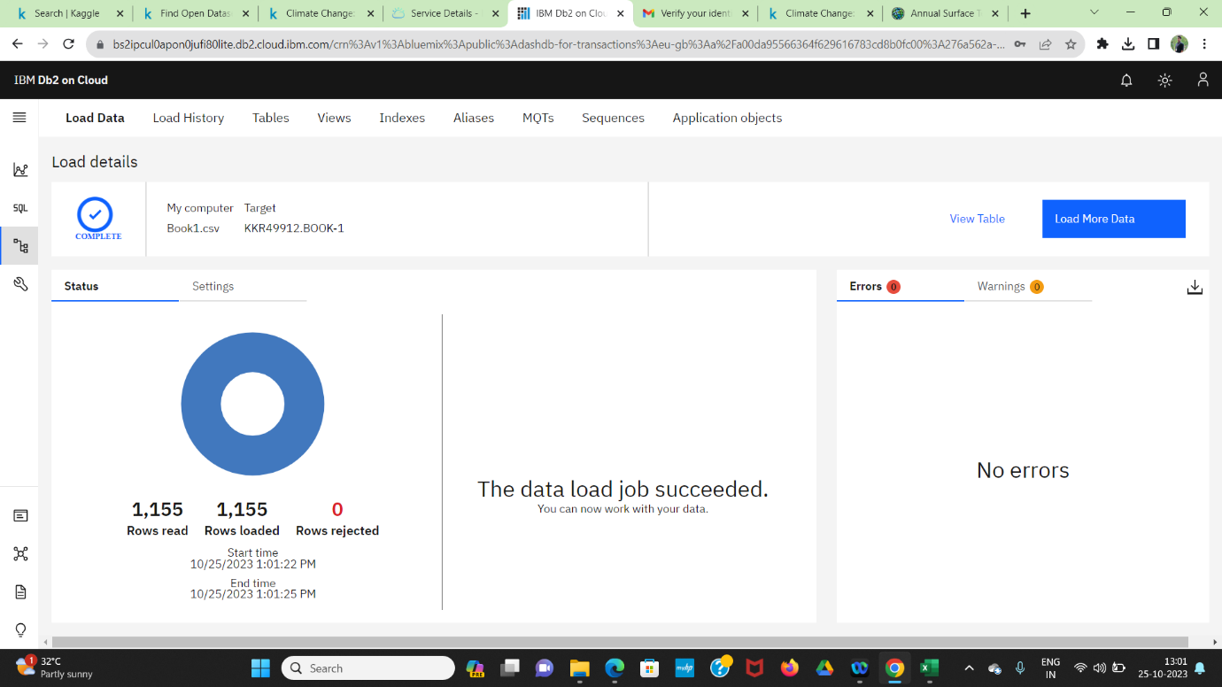

* Click the view table



* Final output file is shown below.

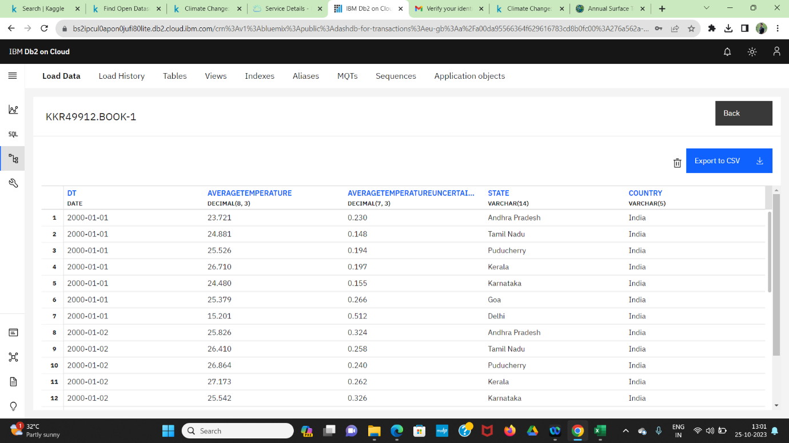

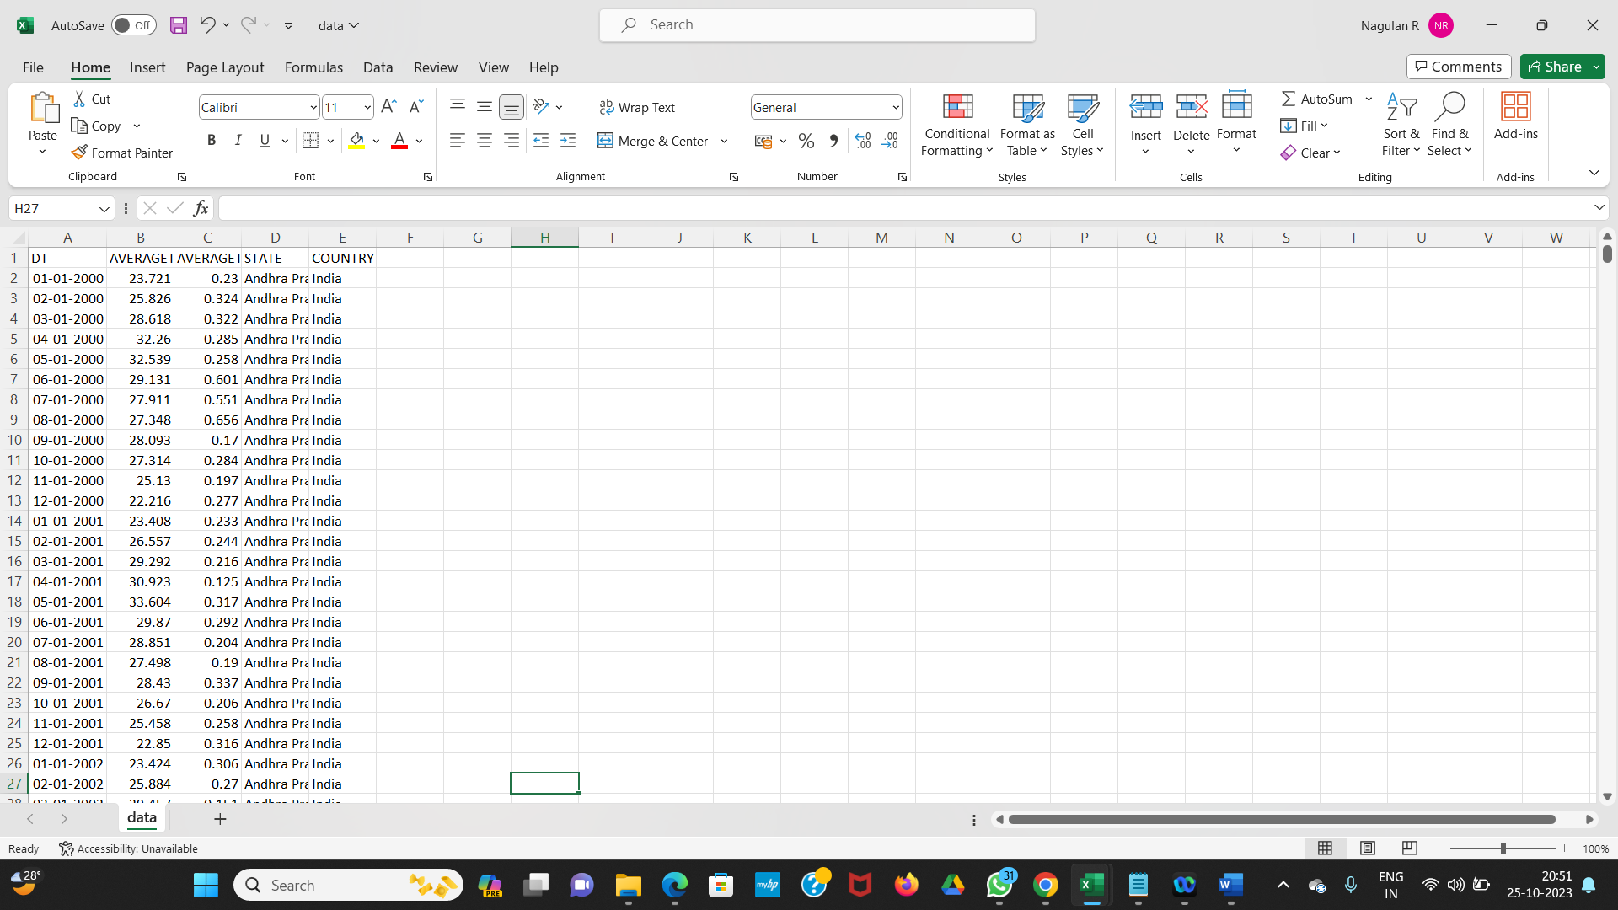

**Development Part 2**

* Building the big data analysis solution by applying advanced analysis techniques and visualizing the results.
* In today's data-driven world, businesses and organizations are constantly seeking insights and actionable information from large datasets. Big data analysis has become a crucial part of decision-making, and IBM Cloud Databases provide a robust platform for building and deploying data-driven solutions. This guide introduces the process of creating a big data analysis solution using IBM Cloud Databases, a multi-step approach to harness the power of your data.

**Step 1: Advanced Analysis**

* To dive deeper into your data, consider applying more advanced analysis techniques. Depending on the nature of your dataset and objectives, you might utilize machine learning algorithms, time series analysis, sentiment analysis, or other sophisticated methods. These techniques can reveal hidden patterns and trends in your data, offering valuable insights.

**Step 2: Visualization**

* Furthermore, visualization is a powerful tool for conveying your analysis results. You can create graphs and charts to make the data more accessible and understandable. Tools such as Matplotlib, Plotly, or IBM Watson Studio can assist in generating visually appealing and informative graphics.

**STEP-1: Advanced Analysis Techniques**

In the analysis techniques phase, you'll decide on and apply the specific methods and algorithms for extracting insights. This includes:

* Choosing appropriate analysis techniques based on your research questions, such as regression analysis for climate.
* Developing custom scripts or utilizing pre-built analytics tools to conduct the analysis.
* Ensuring that you have the necessary computational resources and infrastructure for complex analyses, especially for big data.
* We using the Watson studio for analysis techniques.

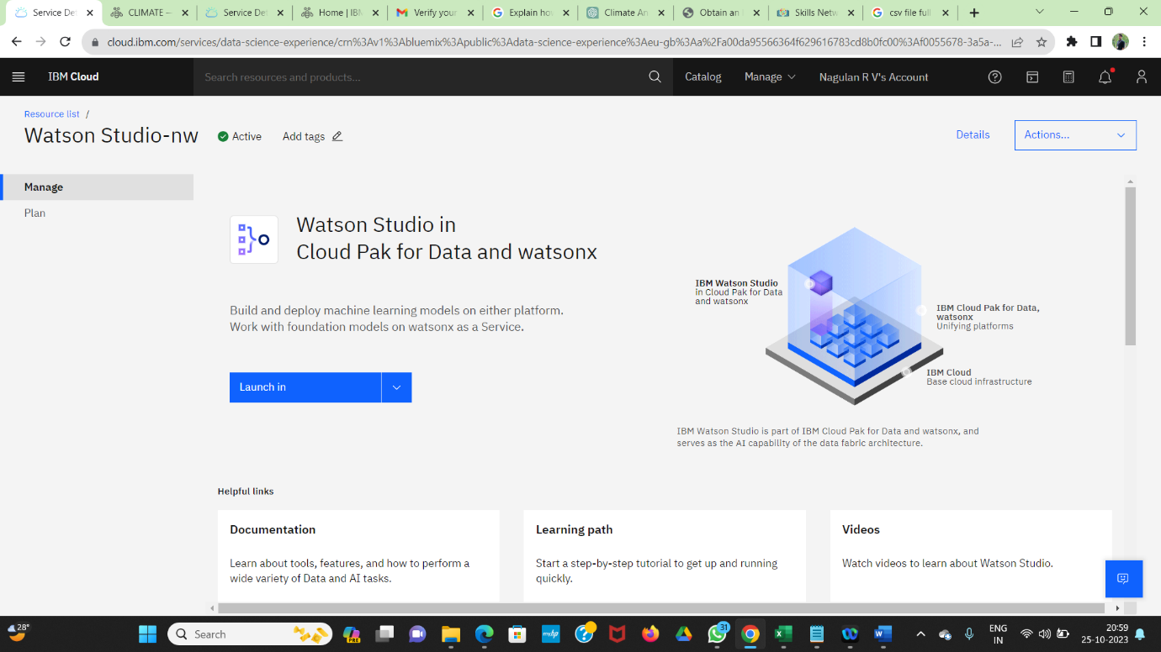

* Click the launch in and click the IBM Cloud Pak for Data

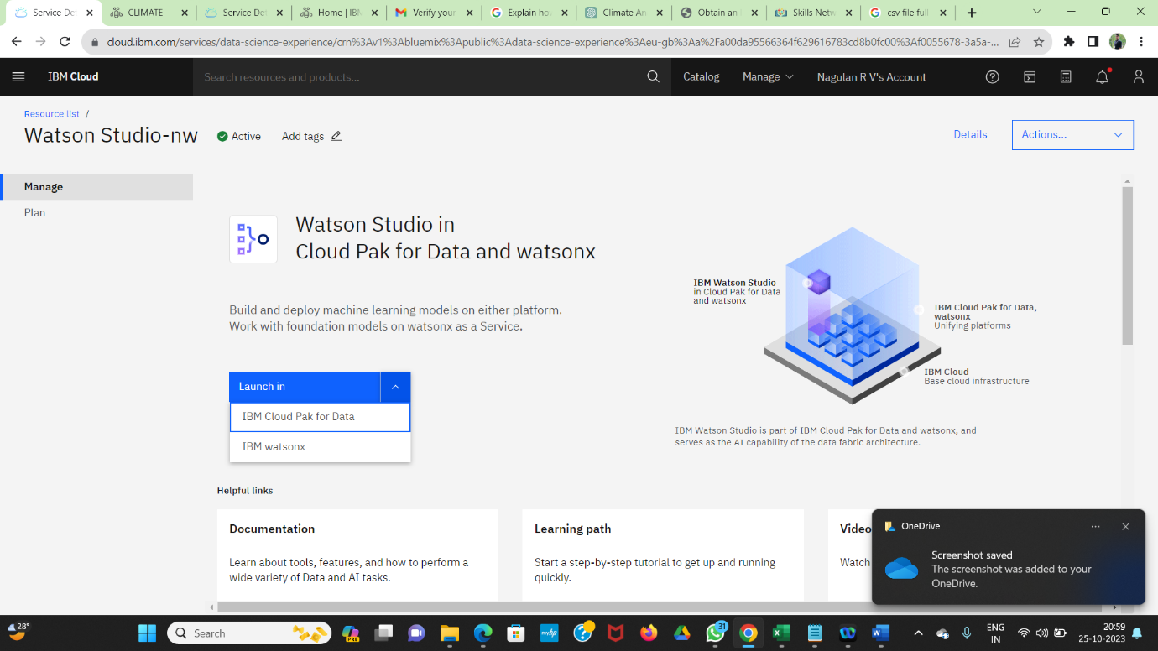

* After that create the new project , before creating the new project you need to create bucket in **Cloud Object Storage.**

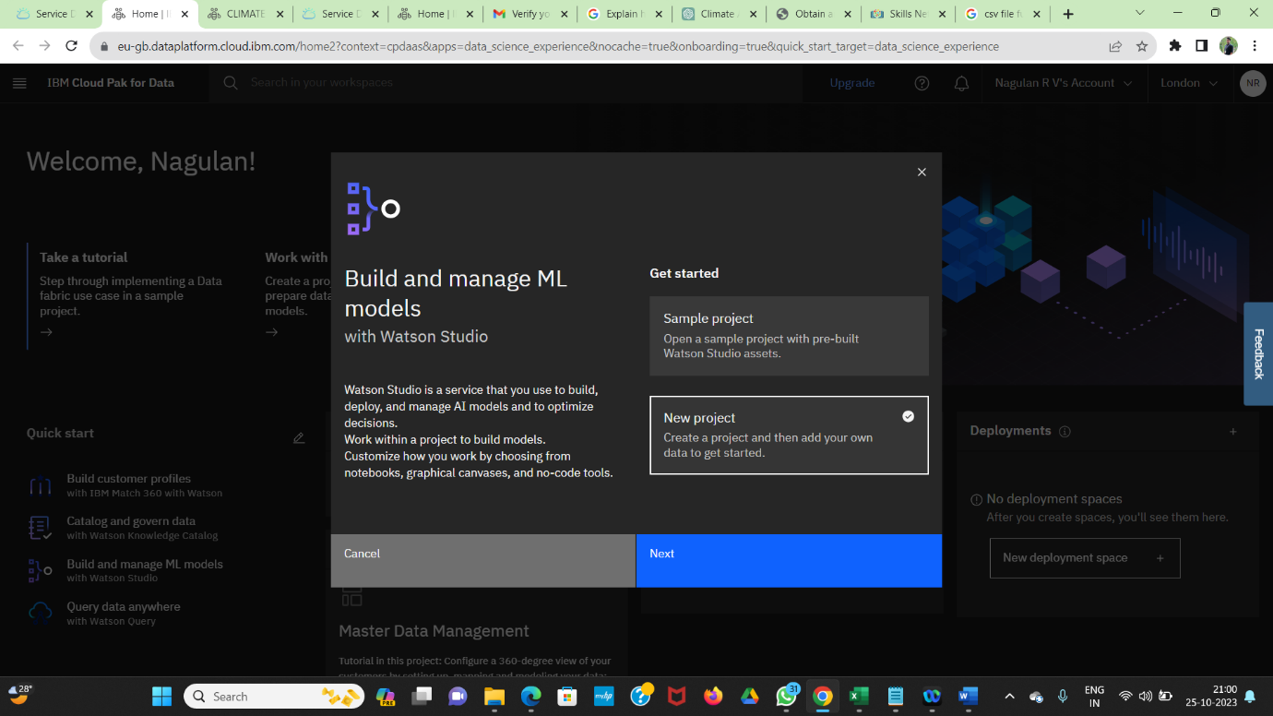

* Name the new project , After click the create button.

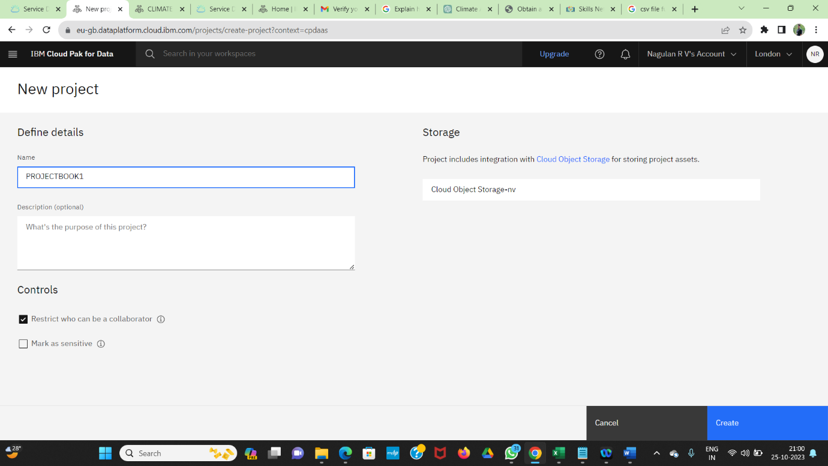

* After the creation click the Assets

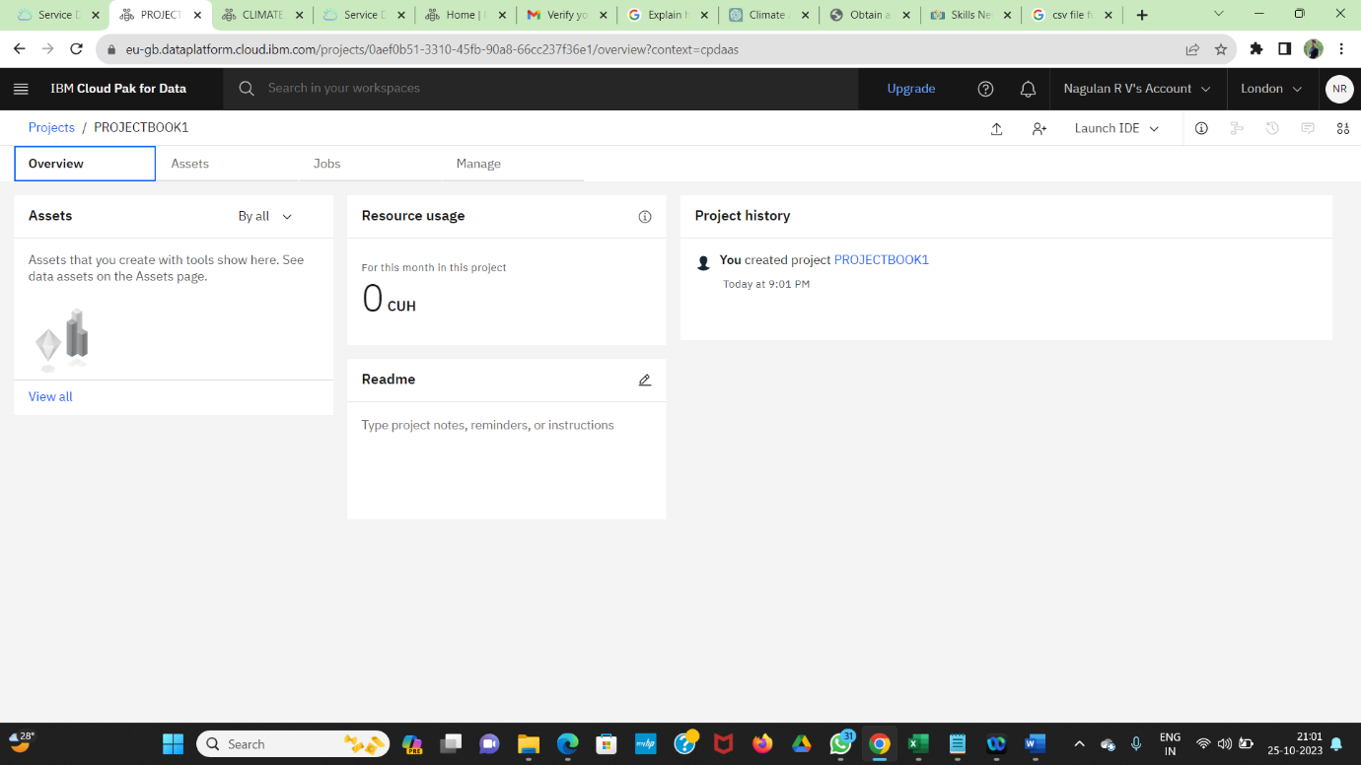

* Drag and upload the file

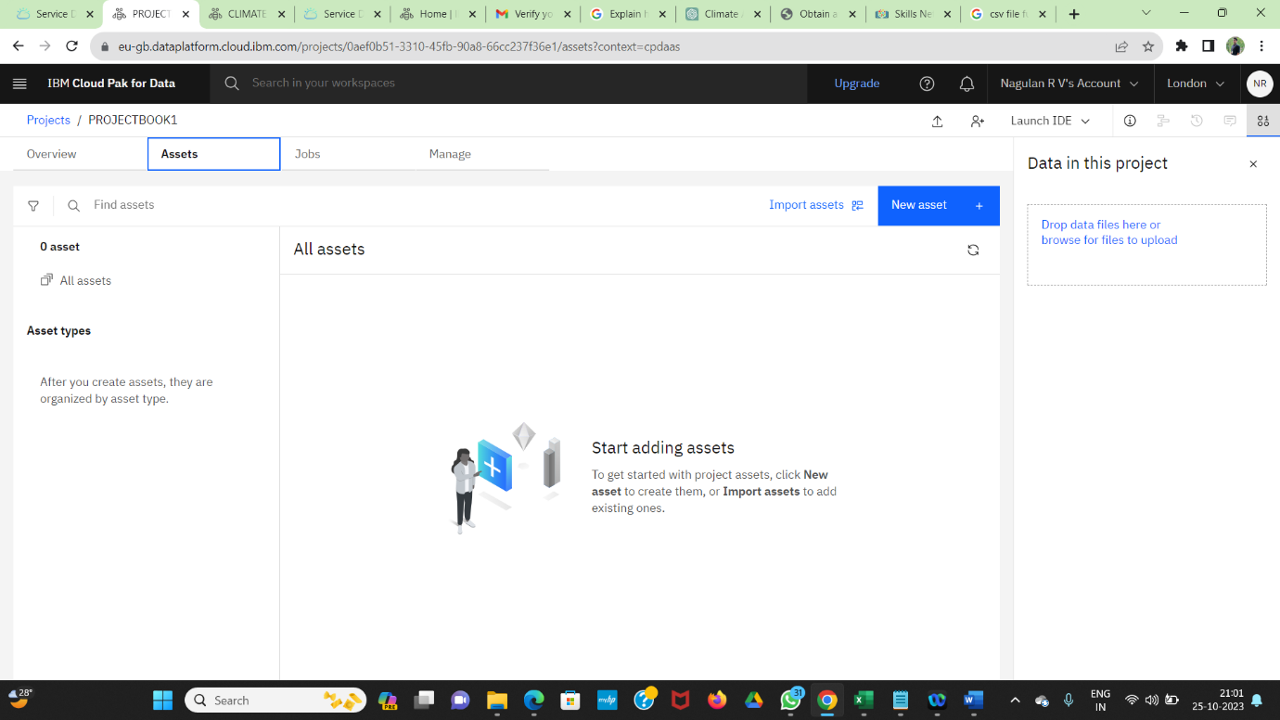

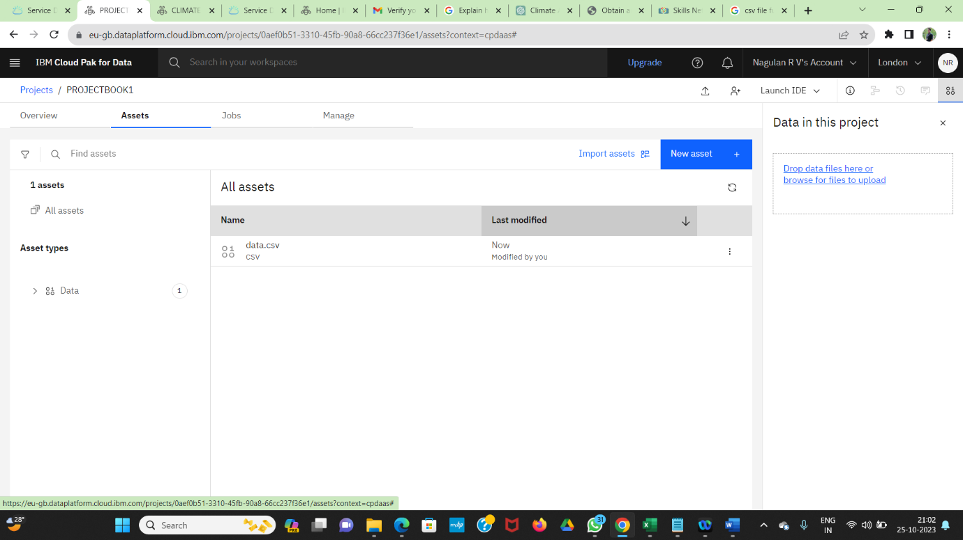

**STEP-2 : Visualization:**

Visualization is crucial for making your findings understandable and actionable. Consider the following:

* Creating visualizations that effectively communicate your analysis results, such as line charts for climate.
* Using interactive tools or dashboards to allow stakeholders to explore the data and insights on their own.
* Ensuring that your visualizations are accessible and user-friendly for a broad audience.
* Click the data file



* It will show the preview asset

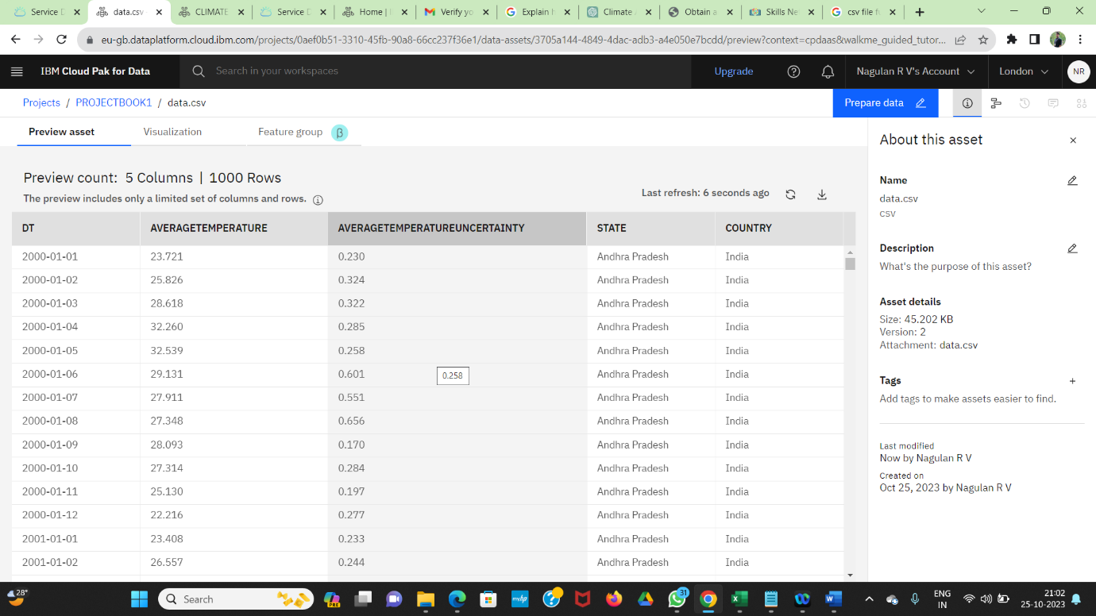

* Click the visualization and give axis.

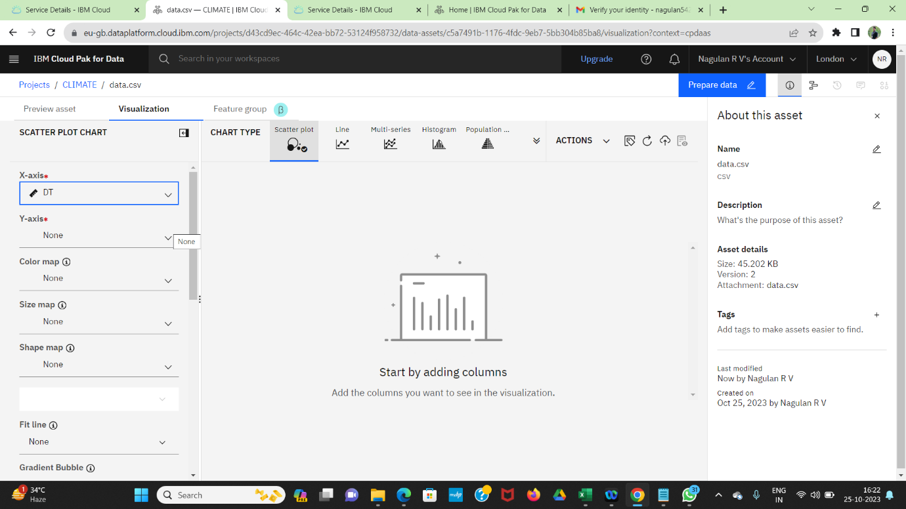

* Example for scatter plot

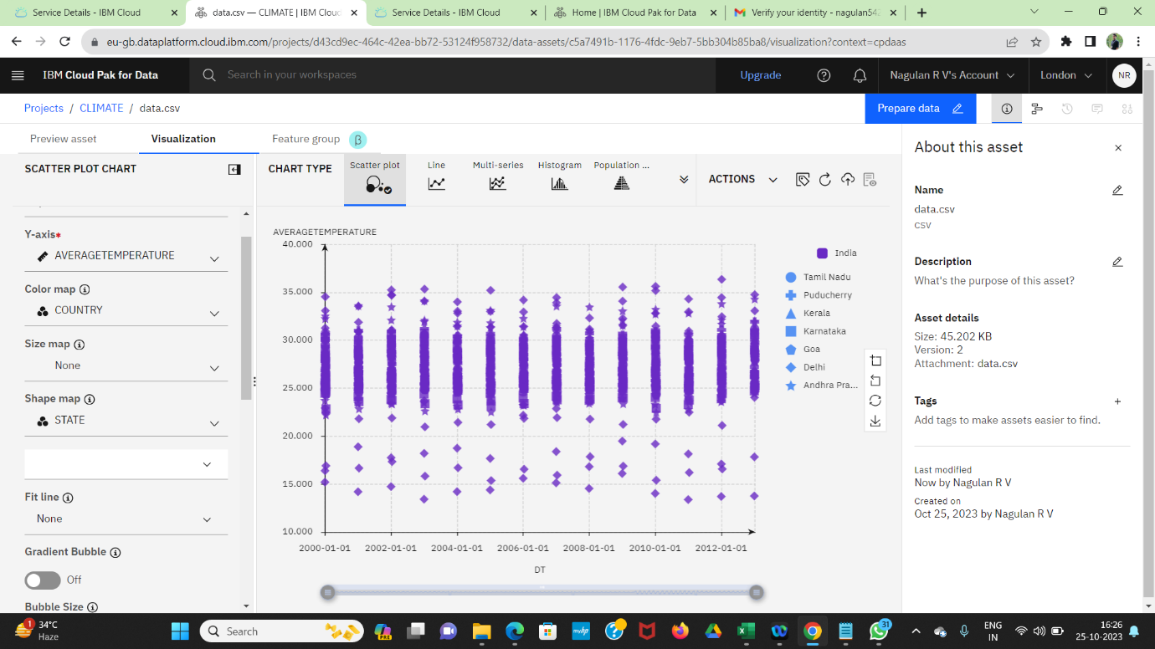

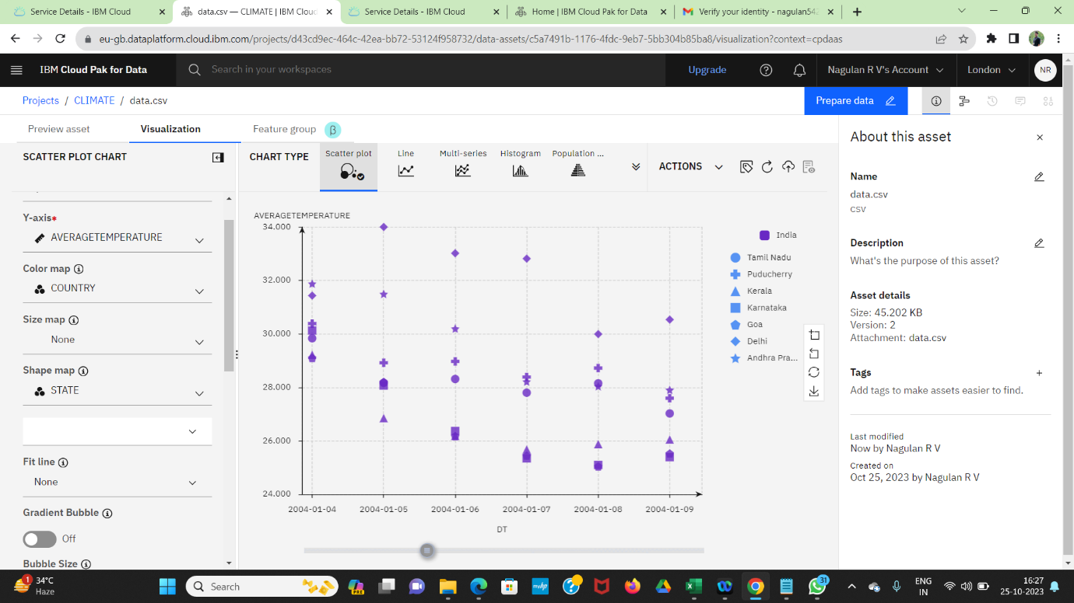

* Example for lime chart

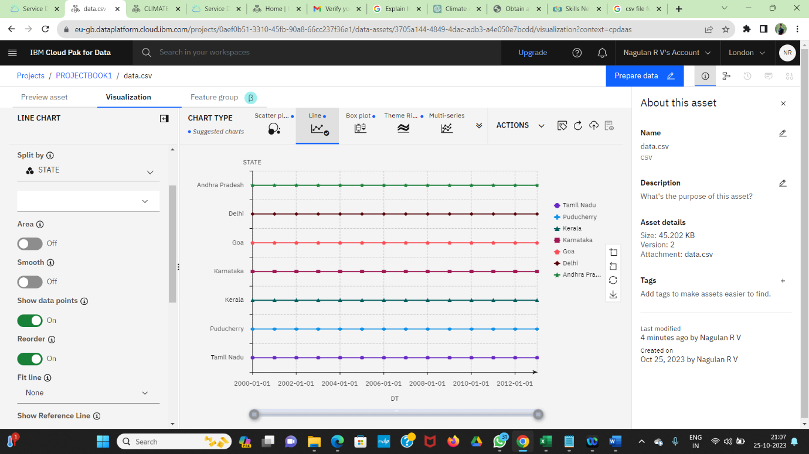

* Example for histography

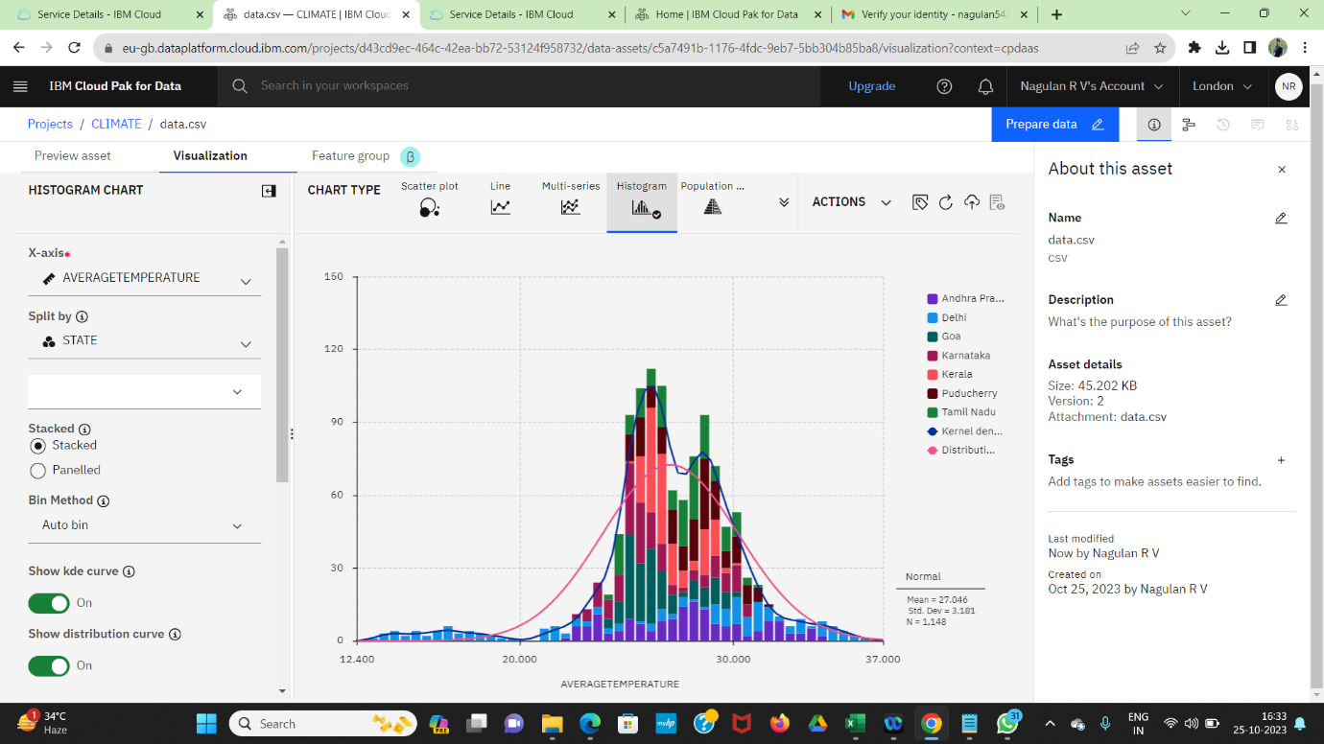

* Example for pie chart

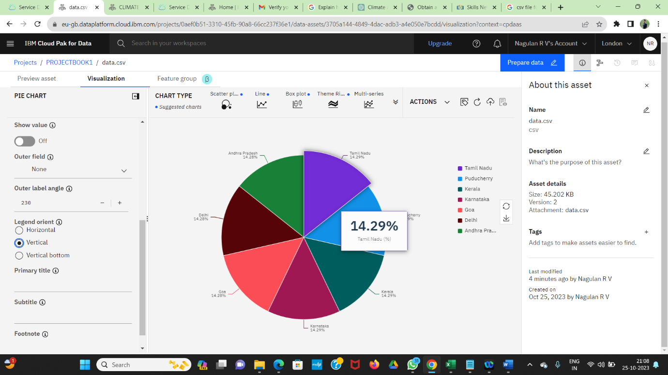

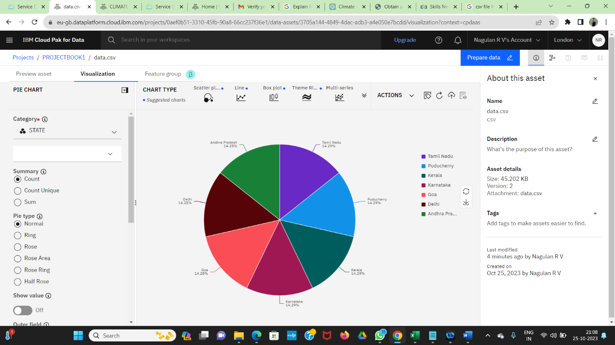

**Business insights.**

1. **Risk Assessment**: By analyzing climate data, businesses can identify potential risks associated with climate change, such as extreme weather events, sea-level rise, or supply chain disruptions. These findings provide valuable insights into what aspects of the business are most vulnerable to climate-related risks.
2. **Opportunity Identification**: Climate data analysis can also uncover opportunities. For instance, recognizing that there's an increasing demand for eco-friendly products or services due to climate consciousness can help businesses develop strategies to tap into this growing market.
3. **Cost Reduction**: Climate data can reveal cost-saving opportunities, such as reducing energy consumption or improving resource efficiency. For example, understanding how weather patterns affect energy consumption can lead to better energy management practices.
4. **Regulatory Compliance**: Businesses can gain insights into current and potential climate-related regulations. Understanding the regulatory landscape helps in ensuring compliance and adapting strategies to align with evolving standards.
5. **Competitive Advantage**: Through analysis findings, businesses can gain a competitive edge by understanding how competitors are responding to climate change. This knowledge can be leveraged to develop innovative products, services, or processes.
6. **Resilience Planning**: Climate data insights inform resilience planning. Understanding past weather patterns and projected changes helps businesses prepare for climate-related disruptions, ensuring continuity of operations.
7. **Supply Chain Optimization**: Climate data can help in optimizing supply chains. By analyzing historical weather data, businesses can better anticipate disruptions and adjust sourcing strategies accordingly.
8. **Stakeholder Engagement**: Insights from climate data analysis can be used to engage stakeholders effectively. Whether it's investors interested in sustainable practices or consumers looking for eco-friendly products, understanding climate-related impacts can guide communication strategies.
9. **Innovation and R&D**: Climate data can inform research and development efforts. Businesses can use these insights to develop new technologies, products, or services that are both resilient to climate change and environmentally friendly.
10. **Sustainability Reporting**: Climate analysis findings are essential for sustainability reporting. Businesses can use this data to track and report on their environmental performance, demonstrating commitment to sustainability.
11. **Resource Allocation**: By understanding the potential risks and opportunities associated with climate change, businesses can allocate resources more effectively. This could involve investing in infrastructure to withstand climate-related disruptions or diverting resources towards sustainable initiatives.
12. **Market Positioning**: Insights from climate data can guide how a business positions itself in the market. For example, a company that actively addresses climate change may be able to differentiate itself and attract environmentally conscious customers.
13. **Cost-Benefit Analysis**: Businesses can conduct cost-benefit analyses based on climate data. For instance, determining the cost of upgrading facilities to withstand extreme weather events versus the potential cost of damage from such events.
14. **Customer Insights**: Understanding climate data can provide insights into customer behavior. For instance, how climate-related events affect purchasing patterns can inform marketing and sales strategies.
15. **Long-Term Planning**: Climate data insights are invaluable for long-term strategic planning. Businesses can anticipate how climate change might impact their operations over the coming decades, allowing for more informed decision-making.

**TEAM LEADER NAME:- ROHITH. J (REG NO. :- 211521104128)**

* TEAM MEMBERS:-

1. S.SAKTHIVEL (REG NO. :- 211521104133)
2. S.SANTHOSH (REG NO. :- 211521104141)
3. K.THARUN VIJAY KUMAR (REG NO. :- 211521104170)
4. B.VISHNU PRIYAN (REG NO. :- 211521104182)